Revision History

|  |  |  |  |
| --- | --- | --- | --- |
| **Date** | **Version** | **Description** | **Author** |
| 05.10.2019 | 1.0 | Assignment of work to Members | Kerem Güre |
| 05.10.2019 | 1.1 | Completed Document overview,  Added some info into Coding and automated tests and Activities and responsibilities | Burak Deniz |
| 06.10.2019 | 1.2 | Added some tools into Software Design (2.2.3) and Coding and automated tests (2.2.4) | Cenker Karaörs |
| 06.10.2019 | 1.3 | Risk Analysis table added | Denizcan Özpınar |
| 07.10.2019 | 1.4 | Added a Gannt Chart, also merged all the revisions so far and did minor fixes and suggestions on them. | Kerem Güre |

**TABLE OF CONTENTS**

Revision History 1

1 Identification 3

1.1 Document overview 3

1.2 Abbreviations 3

1.2.1 Abbreviations 3

1.3 References 3

1.3.1 Project References 3

2 Software Development Activities 3

2.1 Software development process 3

2.1.1 Overview of process phases 3

2.1.2 Technical documentation 4

2.1.3 Deliverables 4

2.2 Software development tools 4

2.2.1 Workstation 4

2.2.2 Requirements management and documentation 4

2.2.3 Software Design 4

2.2.4 Coding and automated tests 4

2.2.5 Configuration management 4

2.3 Software development rules and standards 4

3 Responsibilities 5

3.1 Activities and responsibilities 5

4 Risk Assessment 5

4.1 Risk Analysis 5

4.2 Risk Planning 5

# Identification

## Document overview

This document contains the software development plan of software BCP.

Our project is a web-based project. In our project we want to create a WebApp where people can choose the computer parts they want and buy them. In our web page we aim to create a shopping site like Hepsiburada.

## Abbreviations

### Abbreviations

Add here abbreviations. For example, define an abbreviation for the software system that is going to be developed and use this abbreviation to refer to the system in the rest of the document. You can also add other abbreviations that were previously defined. For example, a list like the following one can be provided.

BCP: Build PC Project

UML: Unified Modeling Language

IDE: Integrated Development Environment

JDK: Java Development Kit

SRS: Software Requirement Specification

STP: Software Test Plan

SDD: Software Design Document

STR: Software Test Report

…

## References

### Project References

| # | Document Identifier | Document Title |
| --- | --- | --- |
| [R1] | ID | Add your documents references.  One line per document |

# Software Development Activities

The section lists and describes the software development activities of BCP software development project.

## Software development process

This is a course project, which adopts the waterfall model as the software development process.

### Overview of process phases

The software development process for the project will be composed of the following phases:

* Planning
* Requirements Analysis
* Design
* Implementation
* Testing and Analysis

These phases will follow each other sequentially, where each phase starts just after the completion of the previous one. The following Gantt chart depicts the planned start date and duration for the phases.

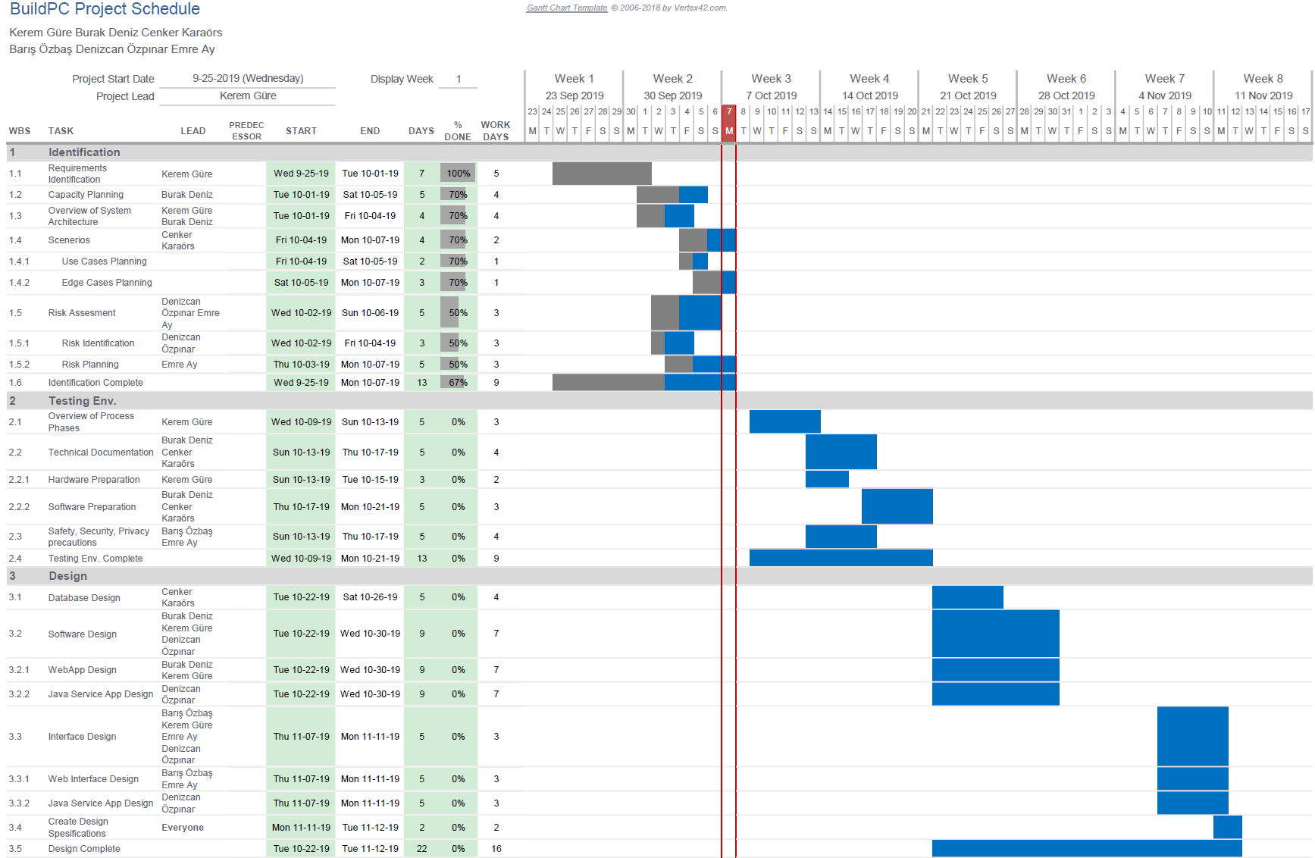

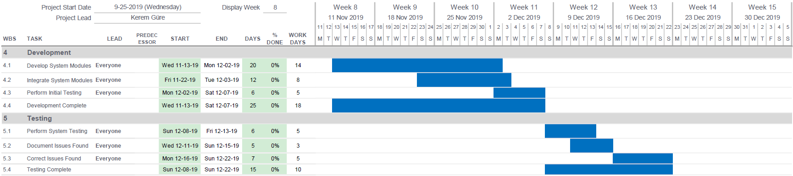

### Technical documentation

The following documentation is produced during the software development phases:

* Software specification: SRS, STP
* Software detailed conception: SDD
* Software tests phases: STR
* Software analysis: SAR

### Deliverables

The following items will be delivered at the end of the process:

* Technical documentation as outlined in Section 2.1.2
* Software and its configuration files

## Software development tools

### Workstation

Describe the typical Workstation used for development

### Requirements management and documentation

Describe tools used to write and manage requirements : Microsoft Word, etc.

### Software Design

Describe tools used for software design :

* Argo UML open source tool, Microsoft Visio, Rational Rose, Together J, etc.

### Coding and automated tests

* PyCharm with Jinja Templates and HTML snippets
* Flask
* Visual Studio Code
* Adobe Dreamweaver
* PhpStorm
* DataGrip
* phpMyAdmin
* Microsoft SQL Server Management Studio

### Configuration management

GitHub[1] will be used for software configuration management and tracking issues regarding the software development. A public repository will be created for this purpose.

## Software development rules and standards

UML[2] will be used for software design documentation.

Describe here other standards and rules you plan to use for software development, if any. For instance, you can follow a particular coding standard/convention (e.g., Oracle provides coding conventions for Java: http://www.oracle.com/technetwork/java/codeconvtoc-136057.html). Then you should mention it here and provide a link for it.

# Responsibilities

## Activities and responsibilities

Each activity has someone responsible (although multiple project members can be involved in the activity), mandatory.

|  |  |  |
| --- | --- | --- |
| **Activity** | **Responsibility** | **Comment** |
| Project management | Kerem Güre | Responsible for the project flow and management such as assignment of work to members and quality control. |
| Configuration tools management | Kerem Güre | Responsible for configuring Github Repos and creating documentations for members to reference when necessary. |
| Setting up the Development tools | Burak Deniz | Responsible for installing all necessary frameworks, plugins, IDEs etc. |
| Software specifications | XXX |  |
| Database design | Cenker Karaörs | Responsible for designing a relational DB that fulfills the given requirements also responsible for writing the queries will be used in later stages of production. |
| … |  |  |

# Risk Assessment

## Risk Analysis

|  |  |  |
| --- | --- | --- |
| Risk | Probability | Effects |
| The time required to develop the software is underestimated. | High | Serious |
| Customer’s requirements may change during development time. | Moderate | Serious |
| Workstation system failure. | Low | Tolerable |
| Code generated by code generation tools is inefficient. | Moderate | Insignificant |
| Software tools may be incompatible with other tools. | Moderate | Tolerable |

## Risk Planning

For each risk item listed in the previous subsection, provide risk indicators and action(s) to be taken when the risk takes place.

1. http://www.github.com
2. http://www.uml.org/